Sample of phrasing technique presented by Kathy Swiney, CCC/SLP, for International Stuttering Awareness Day (ISAD) Conference October 2012 (3 of 3)

Level 3: Visually scan the text before you read it aloud. Any sentence longer than five or six words will need to be broken into phrases or “chunks”. Punctuation marks are visual cues that a phrase is needed. Conjunctions and prepositional phrases are also good places to create a phrase. This isn’t difficult. Just put pauses where it sounds natural to you.

When you read the text aloud, start each phrase with an easy onset. If you start to stutter, relax out of it. Don’t wrestle the stutter.

358 MPG Car Built by Junior High Students
Adapted from foxnews.com, opposingviews.com and KY3 News for educational purposes

Is Detroit looking to teens for ideas? Some consumers think they should be. They won’t have to look farther than Aurora Junior High School. That’s right, a junior high.
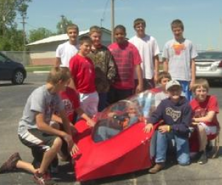
A group of students from Missouri have built a car that gets 358 miles per gallon. Under the guidance of Marcus Reynolds, the seventh and eighth graders from Aurora Junior High School used their creation to win the Missouri Super Mileage Challenge, beating out high school teams from across the state.

The single-seat car weighs 100 pounds and starts with a pull cord. Powered by a motor that is used on motorized bicycles, its streamlined plastic body looks like a high tech ride. Caleb "Rodeo" Baker, an Aurora team member admitted "We were just nervous about our car looking the coolest."
Uncredited photo

Level 4:

- Summarize the article in your own words.

- If your school entered a similar contest, would you participate? Why or why not?

- Do you consider this “green” project a great step toward our future or is this a fake issue created by people seeking government money for experiments that may never work? Support your point of view.

