Patricia Young, PhD, RN and Norma Krumwiede, EdD, RN Professors in the School of Nursing at Minnesota State University, Mankato have created this assignment for their first semester nursing program students. You are free to use the materials with the following citation:

Young, P., & Krumwiede, N. (2016, January 20). Family Construct Poster Presentation Assignment. Retrieved January 20, 2016, from http://ahn.mnsu.edu/nursing/institute/ifna.html

The School of Nursing at Minnesota State Mankato prepares nurses who understand the importance of family and society in health care. The family-focused curriculum and simulation experiences in our bachelor’s, master’s and doctoral programs help students learn how to provide the best care possible to individuals, their families and the community.

Family Construct Poster Presentation Assignment

Topic/Focus:
Creating a poster presentation on a family construct

Intended Audience:
Undergraduate students*

IFNA competency:
#4 and/or #5

Student Learning Outcomes:
- Review current literature related to a family construct
- Synthesize literature related to a family construct
- Identify evidence based nursing actions related to a family construct
- Develop confidence regarding professional nursing practice knowledge dissemination

Description:
The purpose of this activity is to introduce beginning nursing students to the scholarly foundations of family-focused nursing practice and what it means to practice family-focused care. The aim is to generate enthusiasm in students and an appreciation of family-focused nursing care and evidence-based nursing practice. The end result of this learning activity is a poster presented to peers.

Description in course syllabus:
Students are assigned a family construct, search the literature for related information, and develop a poster to present to peers.
1) Review the literature
a) Look at concept/construct first
b) Add family
c) Add family nursing
2) Summarize research findings related to the family construct
3) Define family construct and relate why it’s important
4) Provide exemplar case(s) that shows all facets
5) Make recommendations for nursing practice
6) Pose questions that you feel still need to be answered
7) Provide a reference list

Notes to instructor:
This learning activity can be completed individually or in small groups; we have used groups of four students. The topic is introduced with the Family Construct Project PowerPoint (see below), which touches on searching the literature, describing the search methodology used, and how to organize the poster. Students are provided a template of the poster design (see below) and a web link for tips on how to create an effective poster (see below). (Email patricia.young@mnsu.edu to obtain actual template.) Depending on the level of student, they may need additional guidance on conducting a literature search, synthesizing findings, and relating it to family theory. The construct could be depicted within a particular health and illness experience or more broadly.
An important aspect of this activity is the final poster presentation session during which students are socialized to knowledge dissemination in the profession. Prior to the poster session, the Poster Presentations PowerPoint (see below) informs students about professional etiquette at a poster session. Students are encouraged to wear business casual attire. All nursing faculty and students are invited to attend the poster session presentation. We are able to hang posters in our School of Nursing hallways—we typically have 10 posters created by 40 students. At the poster session, two students stand by the poster and interact with session attendees while the other two students are free to view the other nine posters. After half the time has passed, the students change roles. This way all students have the opportunity to describe, and defend, their work, as well as to learn about other family constructs.

We have provides some sample posters below, but do not make these available to students and caution you about providing too many examples to students as it tends to limit their thinking and creativity. The examples provided are only meant to give you as an instructor something to gauge your expectations of what is possible.
Possible Family Constructs:

Family Struggling
Family Anxiety
Family Burden
Family Care Strategies
Family Beliefs
Family Engagement
Family Protection
Family Uncertainty
Family Balancing
Family Resiliency
Family Caregiving
Family Communication
Family Coordination
Family Coping
Family Crisis
Family Fear
Family Inquiry
Family Relating
Family Reintegration
Family Stress
Family Information Keeper

More information about Family Constructs can be found at: www.familynursingnetwork.org

Measurement/Evaluation:
We evaluate this activity on a pass/fail basis, upon achievement of the learning outcomes. For instructors wanting to evaluate posters using criteria for judging a poster, a sample of possible criteria is included below. We may include up to four “bonus” questions, each related to a family construct, on the final exam.

*This activity can easily be adapted for practicing nurses or graduate students.
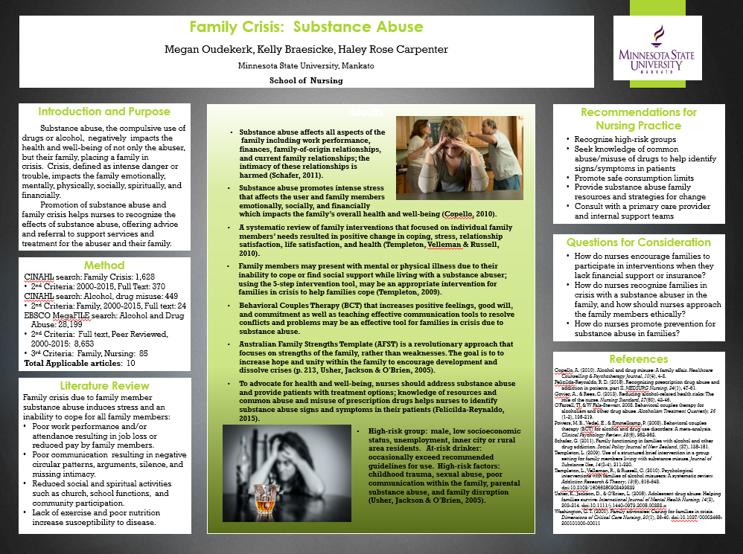

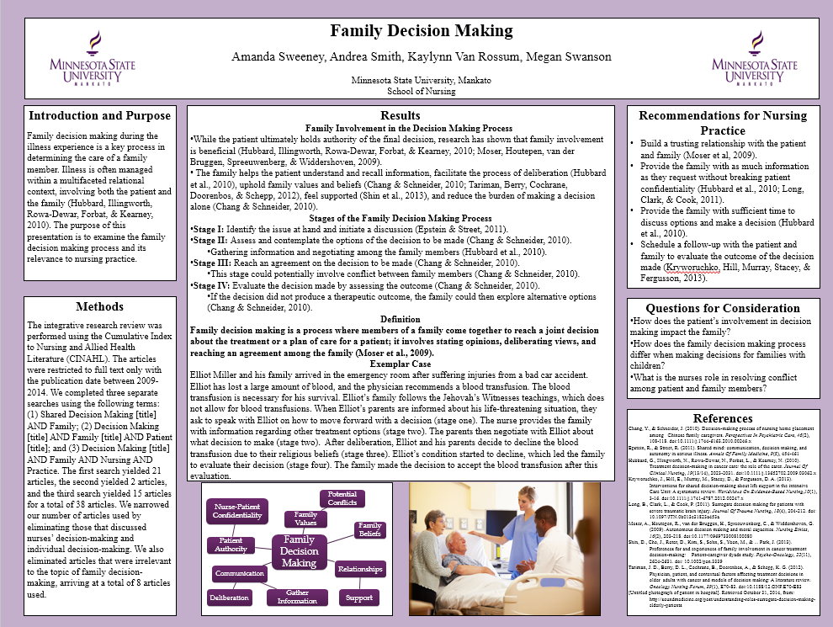
Poster Design Template
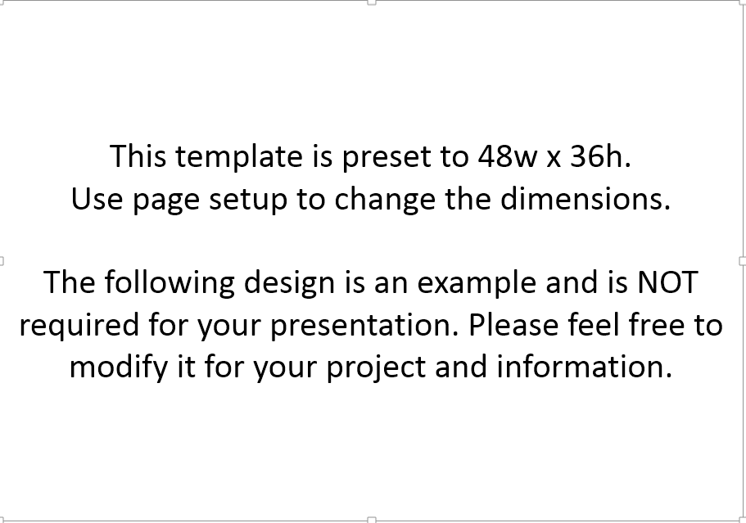
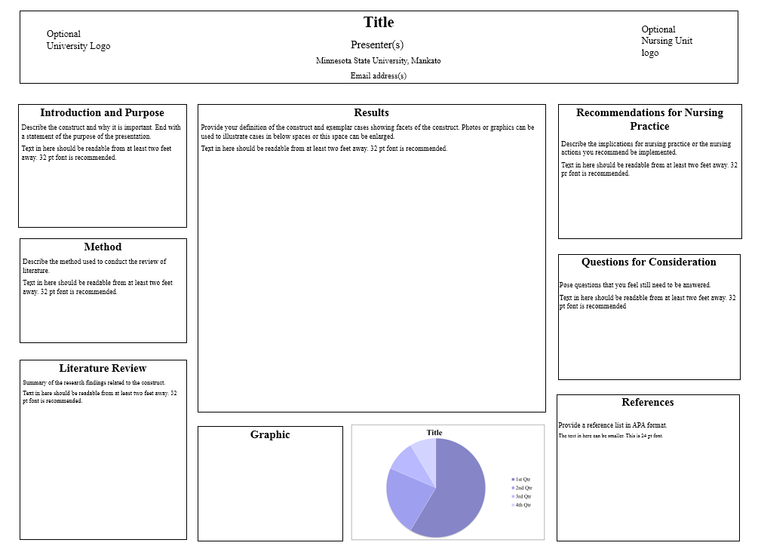Tips for creating an effective poster found here: http://www.ncsu.edu/project/posters

Poster Project Evaluation
Poster projects will be evaluated on the following criteria (1 point each):
- Effectiveness of title in conveying the poster’s subject matter
- Adequacy of background information
- Significance of construct to nursing practice
- Clarity of purpose
- Breadth and depth of literature review
- Clarity of construct definition and relevance to family
- Quality of exemplars in furthering understanding of family construct
- Strength of implications for practice
- Creativity of questions posed
- Appropriateness of references
- Overall visual appeal (balanced and pleasing use of colors, text, graphics)
- Explicit organization and flow of information presented

The following pages are slides and notes that we use when introducing the project to the students. You may use them as they are or adapt them to your teaching style.

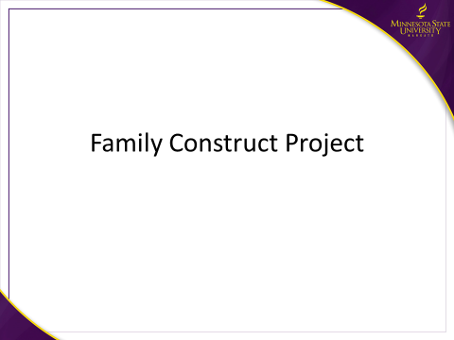
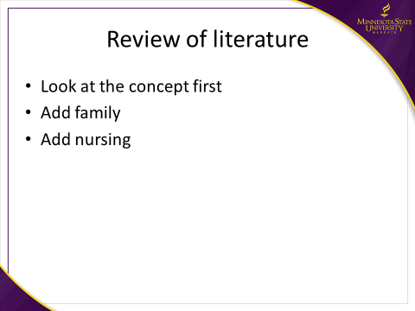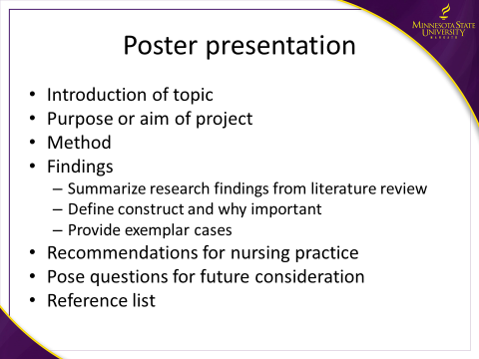
Students may need more assistance with how to review the literature—we include a link to our librarian’s 15 minute overview of how to conduct a search in CINAHL. We review the importance of looking at evidence-based articles, and that nursing actions students may recommend are stronger when based in research.
Students are shown an example of how one could record a search strategy, for instance:
Vieira, Bachion, Mota & Munari (2013). A systematic review of the interventions for nipple trauma in breastfeeding mothers. Journal of Nursing Scholarship, 45, 116-125.

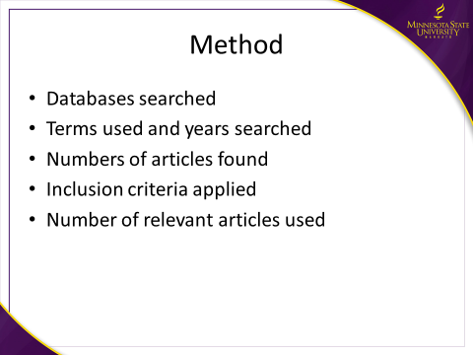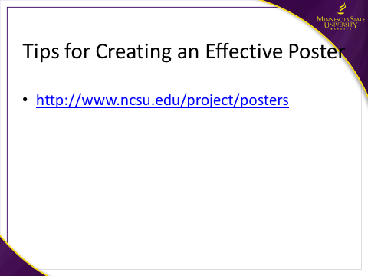
Students are referred to the poster template and the weblink on the next slide (http://www.ncsu.edu/project/posters) for tips on creating an effective poster. Students are encouraged to be creative in their design and that they may resize the boxes on the template, but that all the points should be included.

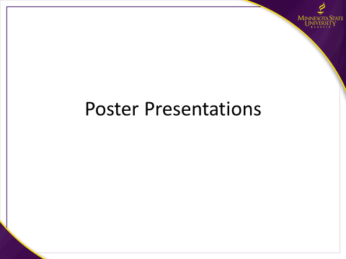

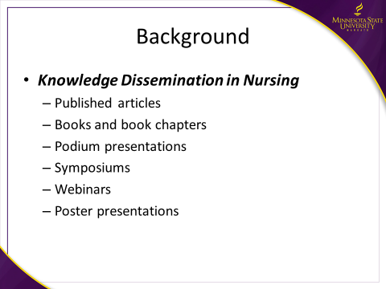
One of the hallmarks of scholarship and being a scholar is making your work public. There are many ways of doing this—most of them are listed here. Students are familiar with the published literature and books. At nursing conferences typically there are three modes of presenting: podium presentations, symposiums, and poster sessions. Podium presentations can be anywhere from 20-45 minutes and address one topic or recently completed study. A symposium is a presentation of three or more related papers addressing a common topic and may run 90 minutes. Poster sessions are opportunities for many people to show their work at once, with conference attendees free to wander and view the work of interest to them.

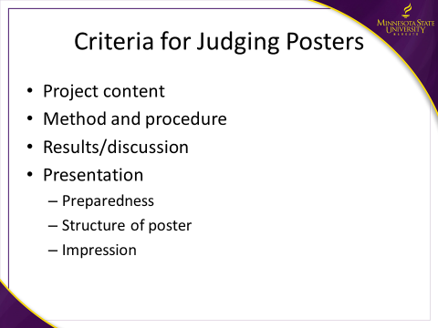
You should be prepared to speak about your topic when attendees visit your poster. It is a good idea to have some speaking points in mind, such as those listed here. You do not want to read your poster, but you might further explain a graphic if you have one. Be sure to allow attendees some silent time to view and read the details of your poster as well. It is great fun when questions lead to a dialogue about your topic and your enthusiasm shines through! This is your opportunity to showcase what you know and what you believe is important for others to know.

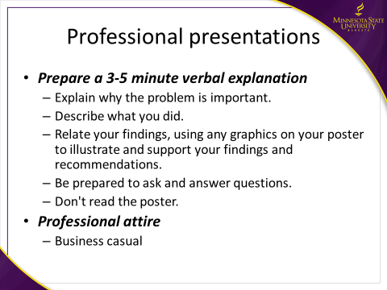
These are some of the criteria that persons might use if judging a poster. Many of the poster sessions at scholarly conferences will be judged, with awards going to the top posters in selected categories.

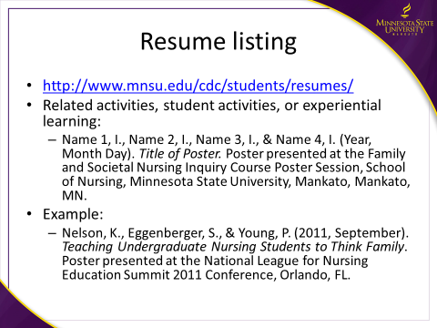
Presentation of a poster could be listed on your resume under a category such as related activities, student activities, or experiential learning. This is how you can list your poster. The link is to the MSU Career Development Center, which has many examples of resumes for students in various fields.

