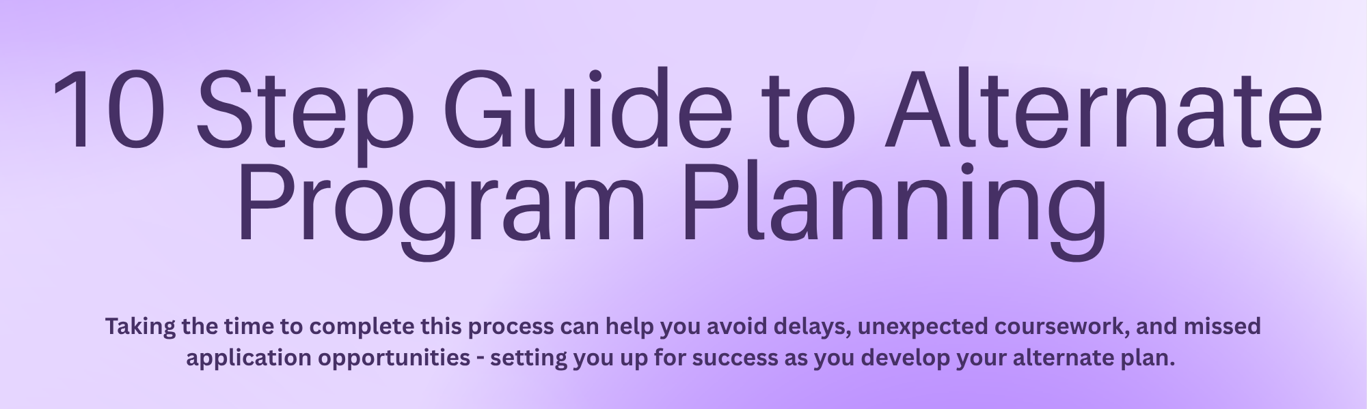
Follow along on the Alternate Planning Worksheet (if possible, link to spreadsheet) to keep track of your research.
 | STEP 1: Identify the Dental Hygiene Program & Key Contacts
Begin by identifying dental hygiene programs that align with your career goals. The American Dental Hygienists Association has a great website to help you explore different programs across the US. Find a Dental Hygiene Program - ADHA
Once you identify a program of interest, start by reviewing the program’s official website to gather both basic program details and contact information for follow-up questions.
Identify the Correct Contact
You will need to communicate directly with the institution to confirm admission and transfer details. Identify who to contact with questions about:
- Dental Hygiene program admission requirements.
- Transfer coursework and prerequisites.
- Course substitutions or exceptions.
- Application policies.
- Competitiveness as an applicant.
Tip:
Look for one of the following roles on the program website: Dental Hygiene Program Advisor or Coordinator, Dental Hygiene Program Admission’s Contact, Transfer Evaluation Specialist, or Undergraduate Admissions Office and keep copies of all emails.
 | STEP 2: Review Costs and Financial Aid
Investigate the financial commitment of the program.
- Tuition cost per credit
- Estimated total program cost
- Available scholarships
Why this matters:
Dental Hygiene programs often have additional fees (labs, uniforms, exams, clinical requirements).
 | STEP 3: Understand Application Deadlines & Criteria
Every program has specific timelines and requirements for you to identify and record.
- Application deadlines
- Application criteria may include:
  - GPA requirements
  - Science GPA requirements
  - English Language Proficiency
  - Required prerequisite grades
  - Certifications or credentials (if applicable)
  - Transfer credit policies
 | STEP 4: Evaluate Prerequisite Courses and Confirm Transferability
Carefully review the prerequisite coursework required for admission. Do not assume courses will automatically transfer to fulfill the intended requirements.
Tool to Use: Transferology
Transferology.com is an online tool that helps students explore how their completed or planned coursework may transfer to other colleges or universities. It allows you to compare how credits apply toward specific majors or degree requirements. Not all colleges or courses are listed.
How to Use Transferology
- Go to transferology.com and create a free account.
- Select "Will My Courses Transfer?"
- Enter Your Course Information:
  - Choose:
    - Your School(s)
    - Term taken
    - Department (e.g., BIOL, CHEM, ENG, PSYC)
    - Course number
  - Enter each course you want evaluated
- Add Courses to “My Courses”
  - Add all relevant completed or planned coursework to your list.
- Search for Matches
  - Search for the college or university you are interested in.
  - Review how your courses may transfer.
Required Actions: Confirming Course Transfer & Evaluation
To receive an official transfer credit evaluation, students generally must apply for admission to the college or university. However, some institutions and dental hygiene programs can provide unofficial transfer evaluations, before formal admission. To determine whether this option is available, follow the steps below.
- Email the Dental Hygiene Program or Undergraduate Admissions Office
  - Use the contact information listed on the program’s website.
  - Clearly state that you are exploring eligibility and transferability.
- Attach Unofficial Transcripts
  - Include transcripts from all colleges or universities attended, including any National Exam scores (e.g., AP, IB or CLEP).
  - Ensure transcripts are readable and up to date.
- Ask How Each Course Will Be Accepted
  - Request clarification on:
  - Direct equivalencies for prerequisites.
  - Courses that may not be accepted.
- Ask Whether Course Substitutions Are Allowed
  - Some programs may allow substitutions for prerequisites.
- Confirm Responses in Writing
  - Request confirmation via email.
  - Save all correspondence for your records.
Best practice:
Use Transferology as a starting point. Always verify transfer decisions directly with the receiving institution.
 | STEP 5: Identify Remaining Prerequisites
Next, you will need to determine the following:
- Which prerequisites are still needed.
- Whether these prerequisites can be taken at your current institution - verify with receiving institution.
- Whether timing aligns with the application cycle
 | STEP 6: Check Special Academic Policies
Every dental hygiene program has academic policies that may affect eligibility such as:
- Course expiration limits
- Example: Science courses must be completed within the last 5–10 years.
- Course repeat limits
- Example: How many times can a course be repeated and what letter grade(s) are used?
- Course type requirements
- Example: Are online labs accepted for science courses?
Important:
These policies can disqualify applicants even if GPA requirements are met.
 | STEP 7: Learn How Admission Decisions are Made
How are students selected?
Questions to Ask:
- Is admission based on a points system?
- Are science courses weighted more heavily?
- Are repeated courses penalized? Or averaged?
- How are ties broken?
- Is there a waitlist?
 | STEP 8: Learn What Makes Applicants Competitive
Understanding how competitive a dental hygiene program is will help you realistically assess your chances of admission and determine whether changes to your academic or experiential profile are needed.
- Number of applicants per admission cycle
  - Helps you understand overall demand for the program.
- Number of students admitted per cycle
  - Gives insight into acceptance rates and seat availability.
 | STEP 9: Evaluate your Competitiveness
Ask yourself:
- Am I currently competitive for this program?
- If not, is there anything I can do to improve?
Examples of improvement strategies:
- Retaking key courses (if allowed).
- Completing additional prerequisites.
Final Reminder
Dental Hygiene programs are competitive, and policies vary widely. Always verify information directly with the program and keep written confirmation of transfer and admission decisions.
 | STEP 10: Apply!
When you have chosen the programs you are interested in and eligible for, apply! You've got this!

